GRANTEE FINAL NARRATIVE REPORT

Grantee Name | Zaštita potrošača
Grantee Number
Grantee Project Name | Enhancing the Rule of Law through Consumer Protection
Grantee Start Date | 15th of September 2017
Grantee End Date | 15th of March 2018
Date of Submission of the Report | 28th of March 2018

*Please note that this is a Final Narrative Report for your Project. We except from you input for all activities realized as part of the Project.

Report received on:
Report approved by:
Date of approval:

- SHORT RESUME OF THE PROJECT AND IMPLEMENTED ACTION
The main goal of the project was to Increase adherence to the law of authorities and companies doing business in Serbia.
Our activities have resulted in major companies such as Whirlpool stopping their illegal activities altogether. Other companies such as Air Serbia, Telenor, Telefónica, S.A. (main Spanish telecommunications provider) have opted to respect the law and the rights of consumers in individual cases that we dealt with.
We have discovered a fault in the billing system used by all cellular networks (mobile) operators in Europe.
Thanks to the fault criminals are able to steal up to € 75,000.00 from the customers of mobile operators. As result of our activities mobile operators in Spain and Serbia have agreed to correct the bills their customers had to pay in the amount that exceeds € 20,000.00.
(see: http://potrosackisavetnik.com/?p=4981)

Increased adherence to the law was achieved by dealing with the following issues:

- Breaches of law by companies
- Unfair business practices
- Low awareness of the consumers about their rights and how they can exercise
- Curtailing of freedom of Consumer organisations to act
- Lack of freedom of media to report about breaches of the law by companies
- Breach of Duty by public officials

Above listed problems were tackled in two principal ways
- First “from the above” by exposing in media how companies and authorities breach the law this putting public pressure on them to respect the law
- Second “from the below” by providing individual consumers with the advice and legal help to ensure that citizens can protect their rights on their own. This also
Following activities for implemented during the project:
Activity 1: Data collection and processing through Consumer Advice Center
Activity 2: Helping consumers to solve problems they have
Activity 3: Production of the TV show for local TV stations
Activity 4: Disseminating information through other channels (YouTube, Facebook, websites etc

Activities had following results:
- 10 TV reports/YouTube videos were produced and aired which reveal how companies break the law and how consumers can protect their rights
- 2 TV reports/YouTube videos were produced and aired about unfair business practices
- 2,219 consumers w get advice and/or other form of help to solve problems they have.
- Three TV stations in Serbia Airing of the TV show about Consumer rights on local TV stations
- S4a: 6 TV 23-minute TV shows produced about consumer rights.

- ACCOMPLISHMENTS DURING THE PROJECT IMPLEMENTATION

  - Describe the activities (as listed in the Form for applying) carried out during project’s implementation. Please specify the location, groups/institutions that were targeted and/or benefited from the activities and the involvement of the partnership in the activities.

Please fill in the table:

Project Objectives | Description of the activities divided by the listed objectives | Date of realization | Place/Location | Groups/  Institutions
Objective 1:  Increase adherence to the law of authorities and companies doing business in Serbia by publicly exposing how they break the law or implement unfair practices | Activity 3: Production of the TV show for local TV stations | 15th of March 29, 2018 | Office and filed work
 | Activity 4: Disseminating information through other channels (YouTube, Facebook, websites etc | 15th of March 29, 2018.  Activity is still ongoing | Office
Objective 2:  Raise awareness of consumers through media about their rights and how they can exercise them on their own | Activity 3: Production of the TV show for local TV stations | 15th of March 29, 2018 | Various locations across Serbia
 | Activity 4: Disseminating information through other channels (YouTube, Facebook, websites etc | Ongoing | Office
Objective 3:  Raise awareness of individual consumers about their rights and help them to protect them through one on one contacts, advices and help with paperwork (submitting complaints to companies or authorities etc.) | Activity 2: Helping consumers to solve problems they have | 15th of February 2018 | Office, filed
 | Activity 1: Data collection and processing through Consumer Advice Center | 15th of February 2018 | Office
Objective 4 Expand media freedoms to report about abuses of the law by companies by increasing availability of media content about abuses of the law by companies in traditional media outlets, on YouTube, social networks and websites | Activity 3: Production of the TV show for local TV stations  Activity 4: Disseminating information through other channels (YouTube, Facebook, websites etc | 15th of March 29, 2018  15th of March 29, 2018.  Activity is still ongoing | Office, filed  Various locations across Serbia
Objective 5  Expose shady relations between consumer organizations, the government, state owned and other companies. | Activity 3: Production of the TV show for local TV stations  Activity 4: Disseminating information through other channels (YouTube, Facebook, websites etc | 15th of March 29, 2018.  Activity is still ongoing | Office, filed

- ACCOMPLISHMENTS ACCORDING TO THE ANITICIPIATED RESULTS:

  - List the most significant accomplishments according to the anticipated results because of project’s implementation. Make sure to describe shortly the accomplishments based on the expected results.

- Anticipated Results number 1
Accomplishments:

S1: 10 TV reports/YouTube videos produced and aired which reveal how companies break the law and how consumers can protect their rights
S2: 2 TV reports/YouTube videos produced and aired about unfair business practices

We have produced 10 TV reports/YouTube videos that revel how companies break the law and how consumers can protect their rights and two about unfair practices. Those reports are:
No. | Name | Lenght | Link
1 | Da li Tehnomanija isporučuje razbijene televizore? | 0:03:50 | www.youtube.com/watch?v=-fnZEHelHD8
2 | Barselona Krađa Telefona 1800000 račun | 0:08:10 | www.youtube.com/watch?v=b9Am7-rBtC8
3 | AirSerbia priznaje štetu ali nadoknadu ne isplaćuje | 0:04:40 | youtu.be/fJDEIYVijLo
4 | Republika Srbija prodaje ukradena vozila | 0:04:55 | www.youtube.com/watch?v=FknUpDG_7Ac
5 | Indesit - petogodišnja garancija, a traje dve godine | 0:03:21 | www.youtube.com/watch?v=v5Mj2Kngk8U
6 | Telefoni strana tržišta LG Samsung | 0:06:21 | www.youtube.com/watch?v=jVBuoXECgH0
7 | Do usluga Telekoma uz falsifikovanje potpisa | 0:04:26 | www.youtube.com/watch?v=QuMfplCvGhQ
8 | Kada dugujete Telekomu krivi ste dok ne dokažete suprotno | 0:04:00 | youtu.be/8nRdymVNgg8
9 | Fiskalni računi blede, a sa njima „blede“ i garancije | 0:04:53 | www.youtube.com/watch?v=-fnZEHelHD8
10 | Lekari kao promoteri proizvoda | 0:06:45 | www.youtube.com/watch?v=NVundk9GmPo

Below we have described in more detail few reports that we feel to be more notable. First one we consider to be of importance to all consumer in Europe because it involves all operator of mobile networks on the continent.
A fault in the billing system used by cellular networks (mobile operators)
We received a complaint from a Telenor mobile network user that he got a bill for one month in excess of 1,800,000.00 RSD (€ 15,200.00). Analysis of the phone records (listings of calls) has shown:
- The thief(s) have managed to make over 270 hours of calls within just eight hours before the SIM card was blocked.
- Over 99% of the amount that was billed to the customer was due to sets of up to 10 parallel phone calls made to just one number in Sierra Leone.

Telenor refused to comment this case. At that point, we were not able to influence Telenor to reduce the bill nor to prove that there is something wrong with software used by mobile operators with data from just one case. Next, practically same, complaint we got was, from a user of Telekom Serbia network. It turned out that he also went to Barcelona, just a year later. We found one more similar complaint in our records by a person who went to Austria in 2011.
In all three cases, operators refused complaints from their users stating that the billing was done accurately and have insisted that bills must be paid. After analysing all records, we have concluded that the cause of the problem is a fault in the system used by all mobile networks thanks to which one can make up to 10 parallel conference calls from one phone (SIM card) to just one number. This fault is used by criminal groups, most notably in Barcelona, to rack up phone bills by making round-the-clock, multiple calls to premium-rate numbers which are owned by them or they have a share of the profits. When we were able to show that a 1,800,000 RSD bill is a consequence of a fault in the software mobile operator use all companies agreed to write off the bills in question.
Outcomes of our action:
- All operators Telefonica – Spain, Telenor – Serbia and Telekom – Serbia have agreed to write off debts of all users which have submitted complaints to us (in total 2.773.002,00 RSD)
- With Telekom Serbia, we now have a procedure for solving future similar cases

See: www.youtube.com/watch?v=b9Am7-rBtC8
Justification of collecting data.
Without collecting data over a long period, we would not be able to help consumers in this case nor in other cases. Collecting and analysing data gives us chance to determine if something is a systematic problem or just one-off mistake like companies claim when we first ask them about a complaint we have received from their customer.
Stolen vehicles auctioned off by the Customs Administration
In 2014 we have found out that the Ministry of Justice instructed Courts to send stolen vehicles to be auctioned off by the Customs Administration rather than to return them to their owners in the EU (see: http://potrosackisavetnik.com/?p=2947). After our report aired we did not hear of any new cases. In late September 2017 Ms Vesna Praća from Slovenia contacted us because vehicle that was stolen from her is to be auctioned off in Serbia in accordance with a court order.
See: www.youtube.com/watch?v=FknUpDG_7Ac

Sale of second hand and faulty devices as “new” ones by leading retail chains in Serbia
We have stated in our application form that we discovered that leading IT and electronic retail chain in Serbia sells used (refurbished) TV sets and laptops as new ones.
We have reopened that case only to discover that practice of selling refurbished electronics as “new” is quite widespread. It turned out that three out of five leading retailers in Serbia are engaged in the illegal practice. We were also quite surprised by how much leading retail chains engage in the distribution of electronics that do not conform to regulations or do not have the proper paperwork.

We have not managed to produce a TV/YouTube clip about as we have only filmed one person. The decision not to air that report was taken because with only one case retailer Gigatron may get away with it by just saying that it was one off, a mistake and it is not a systematic problem.
Other consumers that have had same problem have decide not to participate in the report. This is due to the fact that retailers have offered them a refund and compensation only if they do not participate in our report.

We will continue to pursue this story/problem.

- Anticipated Result number 2

S2: 2 TV reports/YouTube videos produced and aired about unfair business practices

We have produced two videos that deal with unfair business practice. Both reports have directly contributed to the fulfilment of the Objective 1: Increase adherence to the law of authorities and companies doing business in Serbia by publicly exposing how they break the law or implement unfair practices
First one deals with the way fake “medical devices” and “remedies” are sold and advertised, with the help of doctors. (see: www.youtube.com/watch?v=NVundk9GmPo). Media outlets and doctors are aware that they are promoting fake medical devices which do not have any health benefits.
After we have publicly asked Ministry of Health regarding few “medical” devices, the Ministry has acted to stop further distribution of those devices. The organisation that sold fake medical devices in Serbia also operates in Austria, Hungary, Romania, Slovakia, Slovenia etc. They are able to do so because legislation in both EU and Serbia is inadequate. In most cases, authorities can only stop further sales and close companies. After authorities close them down, same group of people just register a new company. We will take activities to amend laws so that promoting and selling fake “medical” devices becomes criminal offence.
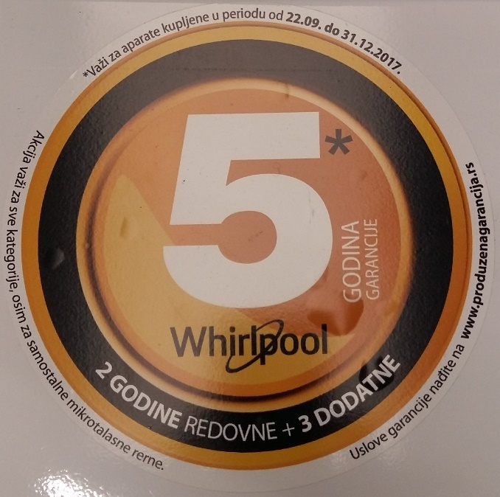
The second deals with the way large international companies such as Whirlpool and Indesit trick consumers into thinking that they have a 5-year warranty. Whirlpool products such refrigerators, washing machines, etc. had a large sticker that informed potential buyers that those products have a 5-year warranty.
Before and after

The problem was that consumers were not informed that they must register their product to have a 5-year warranty and they naturally did not register. Unlucky buyers found out that that they do not have the warranty when their appliance broke.
After we have exposed this practice in a video and pressed Whirlpool with threats of legal actions they have agreed to change the stickers. New stickers include information that buyers need to register products that they bought (see: www.youtube.com/watch?v=v5Mj2Kngk8U).

- Anticipated Result number 3
S3: 1,000 Consumers will get advice and/or other form of help to solve problems they have.

As illustrated in the table below, we have handled more than 2,219 consumer complaints. The figure includes only complaints received via phone and the National Consumer Claims Register. We have not included complaints that we have received via email, Facebook and from the consumers that have visited our office.
Period | Number of phone calls + NCCR (National Consumer Claims Register)
15 – 30  September 2017 | 105
October 2017 | 236
November 2017 | 432
December 2017 | 546
January 2018. | 599
01.-15th of February.2018 | 301
Total | 2,219

Approximately 10% of calls we have received are related to non-consumer issues (e.g. request to provide legal advice in matters such as labour or family disputes, inheritance, etc.).

As can be noticed on the graph below, we have reached maximum capacity in January 2018. If we had more staff, we would have had handled more complaints. One can conclude that before mentioned is true from consumers that complained that they cannot reach us, or that we deliberately hold the lines occupied even when they are not.

We have extrapolated number of complaints show on the graph for September and February so to make those months comparable with to others.

- Anticipated Result number 4 and 4a

S4: Airing of the TV show about Consumer rights on local TV stations
S4a: 6 TV 23-minute TV shows produced about consumer rights.

We have produced in total ten 23-minute episodes of the TV show about consumer rights. Amount of material produced during this action is in line with the plan. More episodes of the TV show have been produced than planned thanks to the support we have received to produce reports that promote energy efficiency, reduction of use of chemicals in households etc. We have combined that material with the material produced during this action to get more episodes of the TV show.

At the moment we have agreements with three TV stations to air our TV show (TV Jasenica as originally planned, TV Kanal 9 from Novi Sad, and TV Santos from Zrenjanin).

Airing of the TV show in ongoing and it will last longer than planned because we have more episodes of the TV program and because production of the TV reports was delayed due to much larger volume of complaints we have received.

- Anticipated Result number 5

S5: 500,000 hits of the website and other internet locations with the content derived from the TV show (views of videos on YouTube, website page visits etc)

Our website had 100.012 visitors during the implementation period.
This is increase of 49.94% from the same period a year ago.

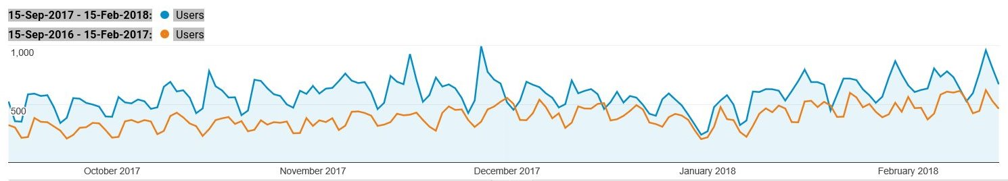
Number of visitors per day to website www.potrosackisavetnik.com source: Google Analytics

Increase in the number of visits to our website was achieved by referring consumers who call us to articles about their problem on our website.
Our YouTube channel did not have the same increase in the number of views. During the implementation period, it had 2.574.876 views, while during the same period year ago it had 2,358,427 views thus the increase is only 9.17%.
That can be explained by the fact that we did not post any new videos. We had to delay posting news videos until TV show is aired because practically all TV stations refuse to air content that was previously distributed.

Number of views of videos on the YouTube Chanel
Period | Number of views | Change in %
15.09.2016. – 15.03.2017. | 2.358.427 | --
15.09.2017. – 15.03.2018. | 2.574.876 | +9.17%

- Anticipated Result number 6

S6: Number of reports produced about problematic relations between consumer organizations, the government, state owned and other companies.

We have produced two reports about problematic relations between consumer organizations, the government, state owned and other companies.

Da li žigovi na proizvodima garantuju kvalitet? http://potrosackisavetnik.com/?p=4831

Pretrpeo štetu od preko 700.000 dinara jer je verovao medijima http://potrosackisavetnik.com/?p=4746

- REFLECTIONS FOR THE REPORTING PERIOD
  - Do you have any kind of problems in the process of implementing the project?
Yes ☒ No ☐
3.2 Do you have any kind of activities that were planned but were not realized?
Yes ☒ No ☐
Please add comments and suggestions of activities not fully completed.
Activity 4: Disseminating information through other channels (YouTube, Facebook, websites etc.) was not completely realised because of the delay in the production of video material caused by the much larger volume of complaints we have received.
We have produced and posted all media content on the internet as planned now it is just a matter of releasing it parallel with the release of the TV show and press.
The main reason why we do not release all material at once is that we want to produce maximum impact by combining release of the media content on the internet, with airing on the TV station and press releases.
We have agreed with quite a few national media outlets to release our media content through their channels. The drawback is that we have to align our dynamic with theirs. This means release one story per week.
We have already released two stories via specialized inserter “Consumer protector” in daily newspaper Informer. The first article was about already mentioned way in which Whirlpool and Indesit have misled consumers.
One can see the article at http://informer.rs/vesti/zastitnik-potrosaca/361583/produzena-garancija-cista-za-ebancija-kupci-gube-pravo-na-dodatni-garantni-rok-jer-im-niko-ne-kaze-da-treba-da-se-registruju-za-tu-uslugu
The article was released earlier to put pressure on the decision-makers in those companies.
Release of our report will follow later to keep up pressure on decision makers to continue to respect consumer rights.
This will not cause any additional cost it will just require time.
  - What obstacles encountered in the process of the project implementation? Were you able to address these obstacles? If yes, how? If no, why?
One of the more formidable obstacles that we face is the lack of will on the part of consumers/citizens to raise their voice and pursue their rights.
This is particularly problem with our ongoing investigation regarding sale of second-hand electronics or devices that do not conform to standards i.e. devices that cannot function properly in Serbia or the EU (e.g. mobile phones made to Chinese 4G LTE standards that differ from those in Europe and thus do not support 4G data speeds on mobile networks in Europe).

The problem is that when consumers inform retailer that we told them that their “new” device is a second hand one and that we are doing a report about it, retailers go out of their way to get back device from the consumer. They offer to replace the devices with better one free of charge and/or financial incentives.
Consumers find it hard resist not to take a better device or money.
The consequence is that we are left without a “smoking gun” (i.e. evidence) and this we cannot pursue the matter.
During the project implementation, we have filmed one consumer. This, however, is not enough to publicly claim that problem is systemic.
We will continue to work on the case and eventually we will find more consumers to film. The second activity we will take is to securing funding so that we can buy devices and thus acquire sufficient evidence.

  - Reflections and lessons learned (Looking back on the design and implementation of your project, what would you do differently? What aspects of the project should be approached differently in a similar situation in the future?)

In investigative journalism, one cannot predict how the story will develop neither in terms of timeframe or outcome. Some stories/cases that we stated to follow will not develop within timeframe of this project (e.g. cases in which problems must be resolved in courts or other procedures will not be completed). Other stories turn out to be dead-ends quite often because consumers lied to us and we can discover that only after filming for couple of days.
One must take into account above mentioned challenges and budget more days of filming and other activities to.
We have underestimated number of calls that we will receive from the consumers.
Number of calls/complaints we receive is increasing quite rapidly over last month. During last week, we have received over 150 complaints. On top of that, three or four consumers come to our offices everyday even though they do not have appointments. This often blocks our work especially when we have two or more consumers visiting us at the same time. It usually takes at least 20 minutes to handle complaint when we have a visit by a consumer, hence we need to set aside one hour per day.
In hindsight, we would align human resources and goals in terms of number of handled consumers complaints differently. We also need to equip our call centre.
We are concerned that we will not be able to keep up the quality of help we provide to consumers.

  - Please share with us the reflections and lessons learned during the implementation of the project (Looking back on the design and implementation of your project, what would you do differently? What aspects of the project should be approached differently in a similar situation in the future?)

Most problems that we had during the project are due to the fact that we have grossly underestimated the number of complaints we will receive from the consumers. In future, we will try to allow more space for “things” to go in unpredicted ways that is for some activities to take more time and resources than planned. Of course, if the budget of the project is sufficient for such “comfort”.

- ATTACHMENTS

No. | Name | Lenght | Link
1 | Da li Tehnomanija isporučuje razbijene televizore? | 0:03:50 | www.youtube.com/watch?v=-fnZEHelHD8
2 | Pretrpeo štetu od 700.000 jer je verovao medijima | 0:05:06 | www.youtube.com/watch?v=t2vJXMKxU1U
3 | Barselona Krađa Telefona 1800000 račun | 0:08:10 | www.youtube.com/watch?v=b9Am7-rBtC8
4 | AirSerbia priznaje štetu ali nadoknadu ne isplaćuje | 0:04:40 | youtu.be/fJDEIYVijLo
5 | Republika Srbija prodaje ukradena vozila | 0:04:55 | www.youtube.com/watch?v=FknUpDG_7Ac
6 | Indesit - petogodišnja garancija, a traje dve godine | 0:03:21 | www.youtube.com/watch?v=v5Mj2Kngk8U
7 | Telefoni strana tržišta LG Samsung | 0:06:21 | www.youtube.com/watch?v=jVBuoXECgH0
8 | Do usluga Telekoma uz falsifikovanje potpisa | 0:04:26 | www.youtube.com/watch?v=QuMfplCvGhQ
9 | Kada dugujete Telekomu krivi ste dok ne dokažete suprotno | 0:04:00 | www.youtu.be/8nRdymVNgg8
10 | Fiskalni računi blede, a sa njima „blede“ i garancije | 0:04:53 | www.youtu.be/cWIuidLaO4Q
11 | Lekari kao promoteri proizvoda | 0:06:45 | www.youtube.com/watch?v=NVundk9GmPo
12 | Da li žigovi na proizvodima garantuju kvalitet? | 0:05:50 | www.youtube.com/watch?v=XsQhgn11oHA

TV Shows
No. | Production code | Lenght | Link
1 | S09Ep21 | 0:23:36 | www.potrosackisavetnik.com/PS/S09/PS_S09Ep21.mp4
2 | S09Ep22 | 0:23:36 | www.potrosackisavetnik.com/PS/S09/PS_S09Ep22.wmv
3 | S09Ep23 | 0:23:46 | www.potrosackisavetnik.com/PS/S09/PS_S09Ep23.wmv
4 | S09Ep24 | 0:22:54 | http://potrosackisavetnik.com/PS/S09/PS_S09Ep24.wmv
5 | S09Ep25 | 0:23:15 | http://potrosackisavetnik.com/PS/S09/PS_S09Ep25.wmv
6 | S10Ep01 | 0:23:10 | http://potrosackisavetnik.com/PS/S10/PS_S10Ep01.wmv
7 | S10Ep02 | 0:23:29 | http://potrosackisavetnik.com/PS/S10/PS_S10Ep02.wmv
8 | S10Ep03 | 0:22:53 | http://potrosackisavetnik.com/PS/S10/PS_S10Ep03.wmv
9 | S10Ep04 | 0:23:23 | http://potrosackisavetnik.com/PS/S10/PS_S10Ep04.wmv
10 | S10Ep05 | 0:23:16 | http://potrosackisavetnik.com/PS/S10/PS_S10Ep05.wmv

No. | Name | Link
1 | Da li Tehnomanija isporučuje razbijene televizore? | http://potrosackisavetnik.com/?p=5295
2 | Pretrpeo štetu od 700.000 jer je verovao medijima | http://potrosackisavetnik.com/?p=4746
3 | Barselona Krađa Telefona 1800000 račun | http://potrosackisavetnik.com/?p=4981
4 | AirSerbia priznaje štetu ali nadoknadu ne isplaćuje | http://potrosackisavetnik.com/?p=5267
5 | Republika Srbija prodaje ukradena vozila | http://potrosackisavetnik.com/?p=5341
6 | Indesit - petogodišnja garancija, a traje dve godine | http://potrosackisavetnik.com/?p=5315
7 | Telefoni strana tržišta LG Samsung | http://potrosackisavetnik.com/?p=5345
8 | Do usluga Telekoma uz falsifikovanje potpisa | http://potrosackisavetnik.com/?p=5390
9 | Kada dugujete Telekomu krivi ste dok ne dokažete suprotno | http://potrosackisavetnik.com/?p=5283
10 | Fiskalni računi blede, a sa njima „blede“ i garancije | http://potrosackisavetnik.com/?p=5276
11 | Lekari kao promoteri proizvoda | http://potrosackisavetnik.com/?p=4781
12 | Da li žigovi na proizvodima garantuju kvalitet? | http://potrosackisavetnik.com/?p=4831

- PUBLICATIONS
Please provide copies of publications and other materials produced in the project. List the number of printed copies as well as the distribution manner. (If needed, add more lines)

Publication 1: Name of the publication
Description of the content
Number of printed copies
Distribution
Link to the published publication | If it is not published online, please send it as annex to this report.

- SUSTAINABILITY OF THE PROJECT
Please describe whether the development of further functioning of the supported Project. Do you plan to realize any kind of planned activities after finishing the project? Do you managed to identify what would be useful and how the project will continue and be sustainable in the future?

We have continued to provide advice and help to the consumers via our call centre thanks to the funding we have ensured during the project implementation and more importantly thanks to the fact that we have managed to employ a lawyer during the project itself.
In cases we deem consumers can successfully protect their rights in courts, we provide them with free representation and when we win we recoup our costs from the other side. Because legal proceedings in front of the courts take a very, very long time we will see the financial benefit at the end of the year.

Material that we have gathered during this project (contracts, consumer testimony, warranty cards, advertising material and other documentation) is being used to support our proposals for the amendment of the consumer protection law. Work on the amendment of the law is a part of the project we are currently implementing “Enhancing the Influence of Consumers on authorities and the Legislative Process”.

- Sustainability of the results of the action (short to medium term)

Media content
Due to the fact that we have posted all of our reports on the internet (video on YouTube and text version on our site www.potrosackisavetnik.com) consumers will be able to find information on how to exercise their rights, when they have a problem, for a long period of time.
The way in which a consumer rights problem can be solved does not change in short-term, hence, the media content we have posted on YouTube and our website will be useful to the consumers in next three to five years.
Changes in the policies of companies will also last at least in the medium or short term. Example of this is the way we solved the problem of Whirlpool and Indesit misleading their customers into thinking that they have a 5-year warranty when in reality they have only a two-year warranty. Under our public pressure Companies have started to properly inform prospective buyers that they need to register their products in order to have a 5-year warranty.

- VISIBILITY

Visibility during the TV show

Closing credits of our TV show are interlaced with the information about how viewers can get in touch with us if they need help to solve a problem that they have. In that way, we ensure that viewers actually watch closing credits. Information about EU support of the production of the TV show, through Action SEE project, is presented at the same time when our contact details are on the screen. This ensures the visibility of Action SEE/EU contribution at the best moment. Below is the screenshot of closing credits which can be seen at: https://www.youtube.com/watch?v=mn-lbievSis

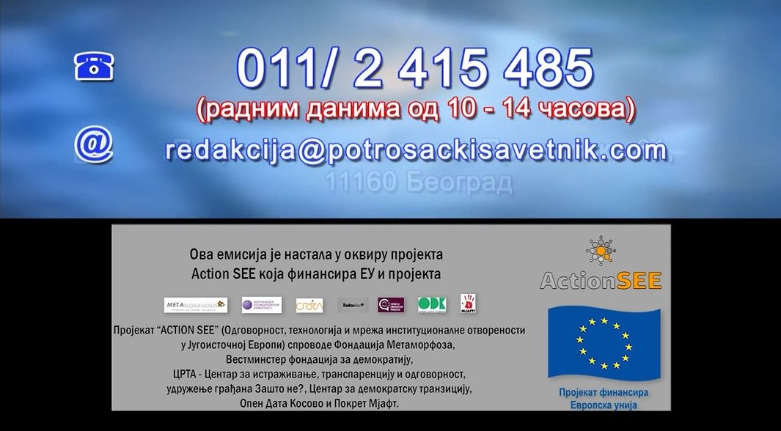

Visibility on YouTube Each YouTube clip ends with the following still

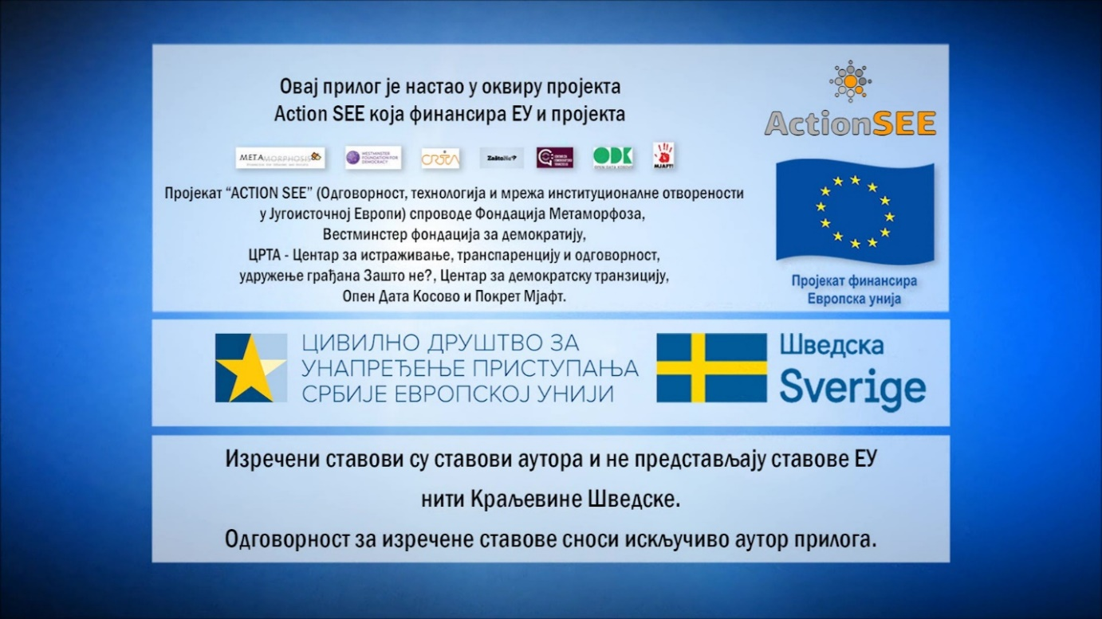
Visibility - texts on the website www.potrosackisavetnik.com
At the end of each text one can see the following:
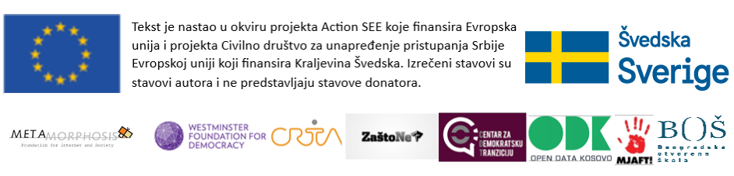

Grantee Program Manager: Nenad Bumbić

Signature:

Report Submission Date: 28 of March 2018.

